How to run the system

To run the system smoothly you must have the following installed on your windows device :

-**MangoDb**

-**postgresql**

The system will run better if you have **cuda 12.4** (for text embeddings) but its optional

Here is how to install and configure the system

PART 1 the Ai logic setup:

Step 1 :

Go to RAG file and click on install.bat make sure you are connected to the internet , this will install all the necessary dependencies in the virtual environment from requirements.txt

(If you run into a problem during the setup of a specific library you may run the install.bat again)

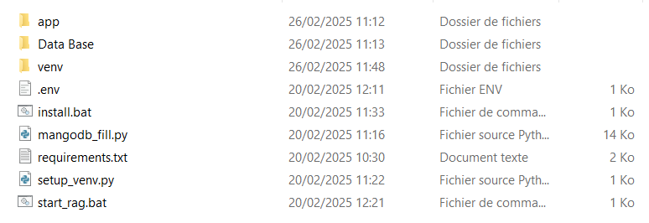

Wait for all dependencies to install, this is phase 1

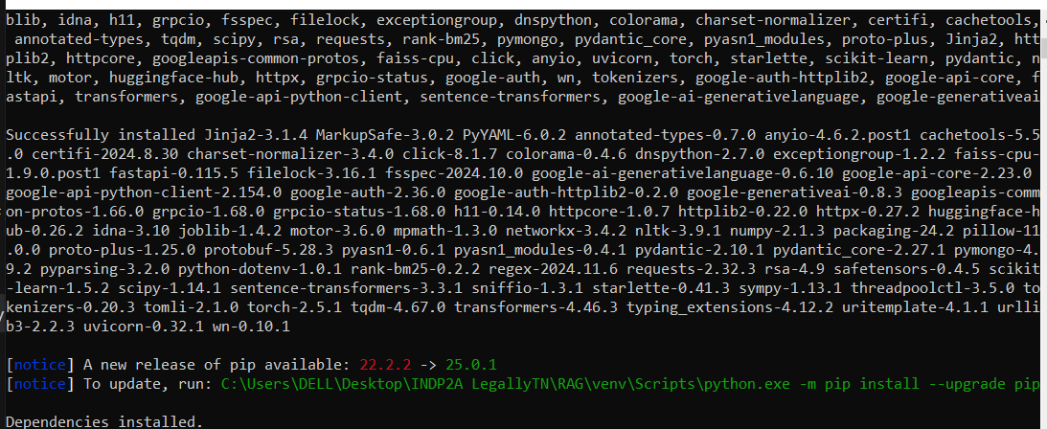

Phase 2 will start automatically , in this part, the system will embed the texts and add them to your mangodb database automatically

If you have cuda , you can wait for all the files of the database to be added as that will run it in your gpu and it will be faster.

If not , wait for 2 or 3 bars (but at least keep one so you may test the system) to load then you may close the program as it will be heavy on your cpu.

The more you let codes be processed the more knowledge the system will have.

“Using device log: “ message will tell whether you are using cuda or cpu.

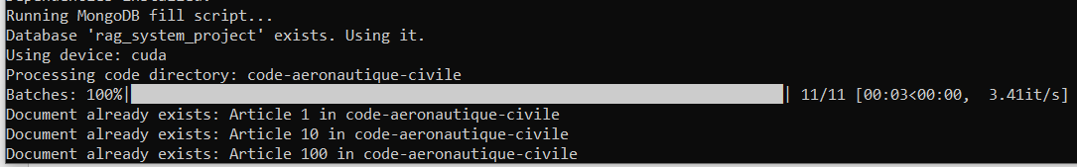

Step 2 (Optional) : testing the server

Click on start_rag.bat and wait until a tab is opened on your browser.

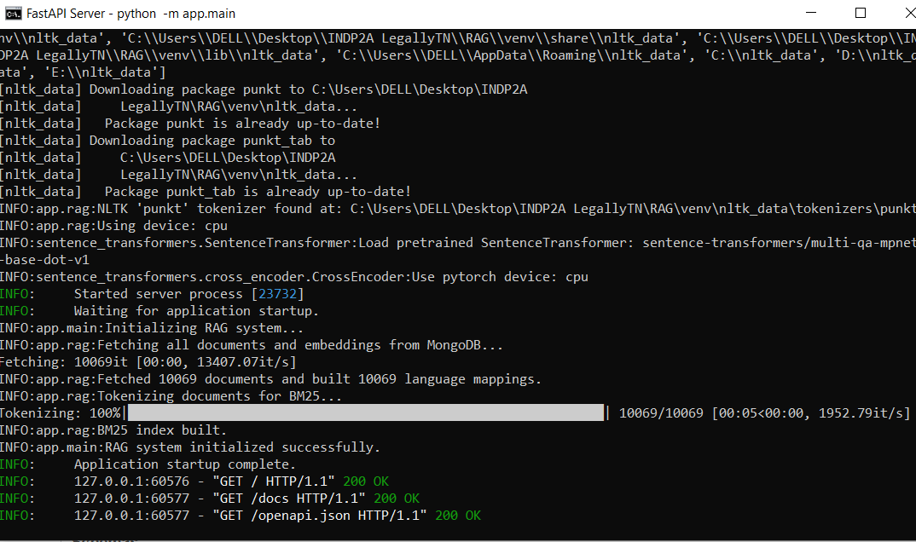

Testing the Api :

You can ask it this question “what does article 5 of the aviation code says ?”.

Make sure topk is equal to 30 like in the following picture.

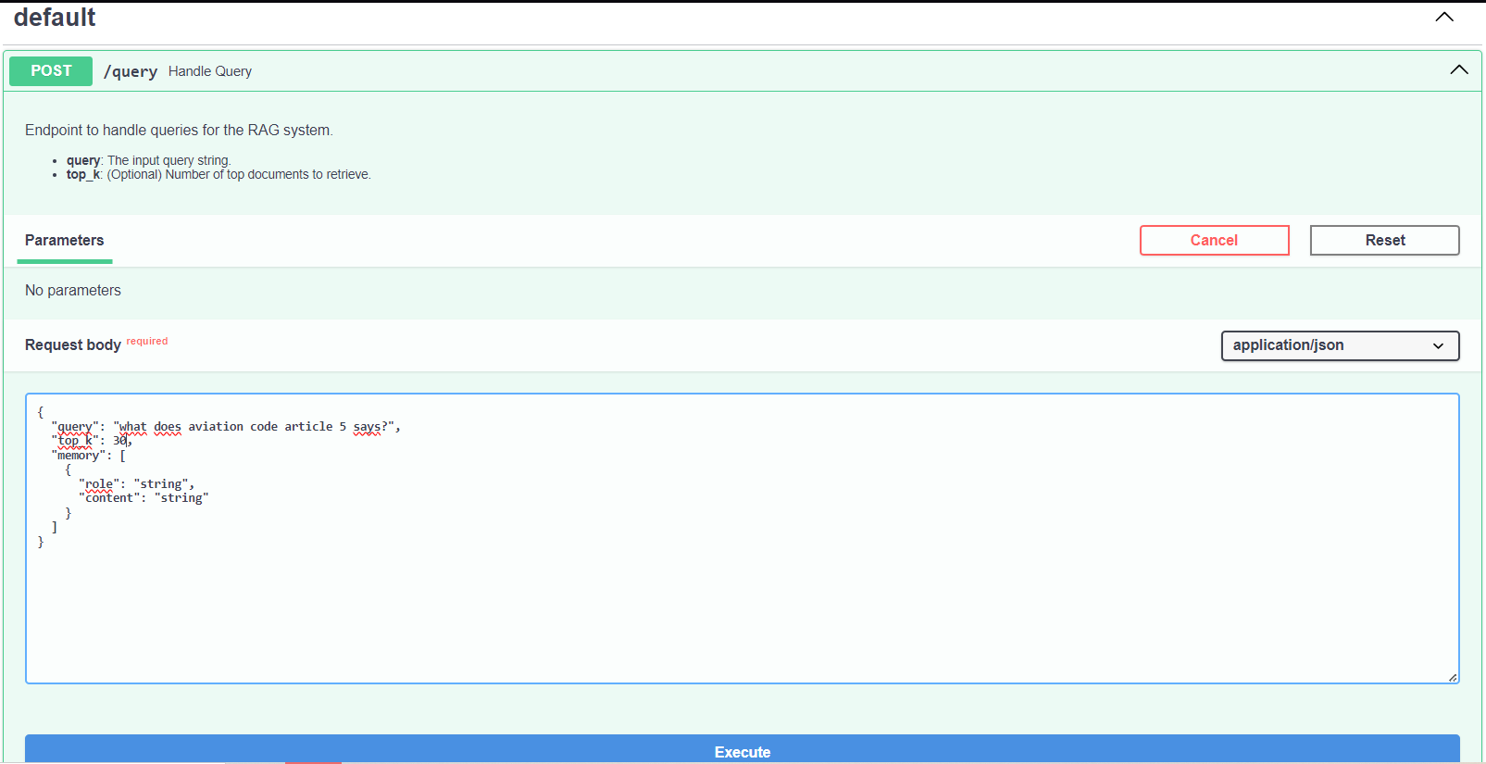

You should get an answer similar to this.

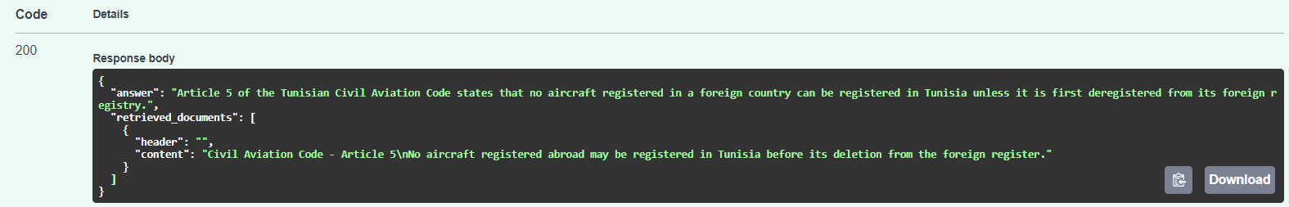

Part 2 : back and front setup.

If you have postgresql on your pc , go to LegallyTN and click on setup_legallytn.bat

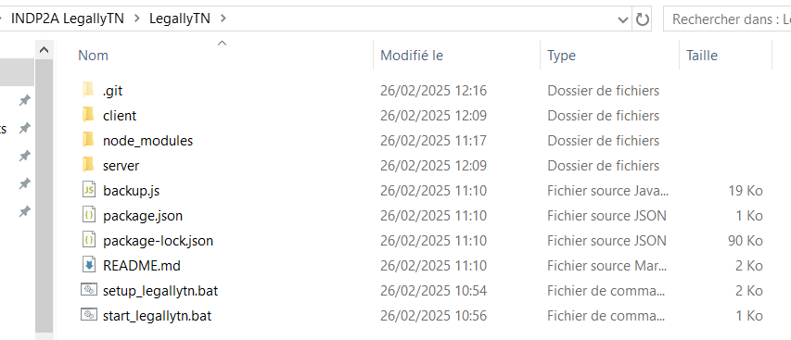

Wait for dependencies to install , database and tables will be created automatically , after it is done it will close on its own.

Part 3 : running the system

Go back to the main folder and click on start_legallytn.bat wait for the server to finish loading and a tab will open your browser.

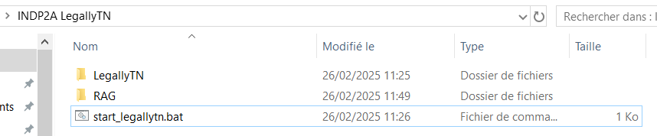

You may create an account and then click “Get started”.

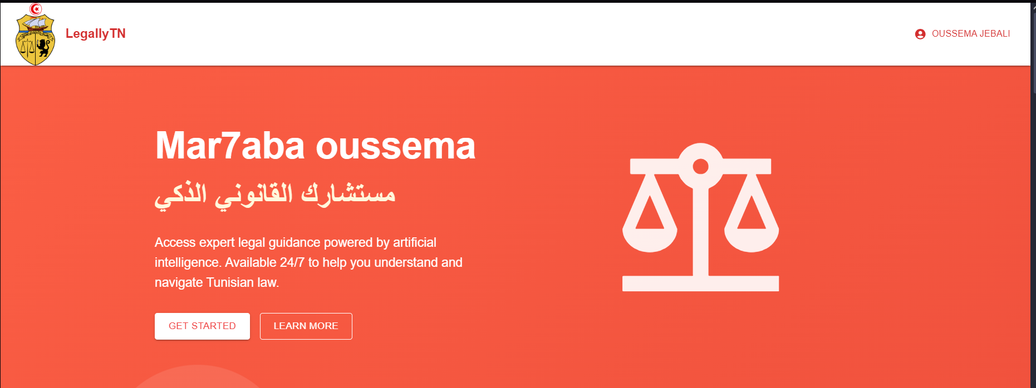

Create a new chat and you may ask the systems any questions from tunisian legal codes.

